A000-Mex-Olmec-Celt-Jade-El Mirador-1100 BCE

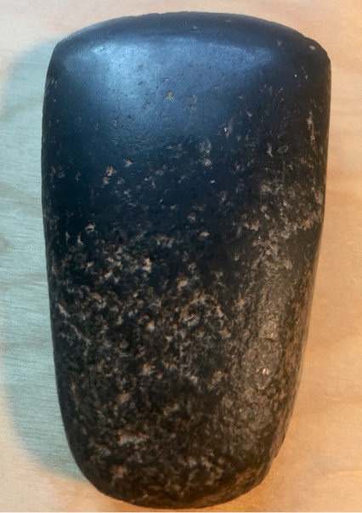

**Case No.: 10**

**Accession No.**

**Formal Label:**

**Display Description:** The jade appears black but it also has tiny traces of green in it. Celts of this smaller size were commonly used as trade currency.

**LC Classification:**

**Date or Time Horizon:**

**Geographical Area:**

**Map:**

**GPS coordinates:**

**Cultural Affiliation:**

**Media:**

**Dimensions:** 55mm x 35mm

**Weight:**

**Condition:**

**Provenance:** Originated from El Mirador site in Guatemala, famous for Olmec and Mayan artifacts.

**Discussion:**

**References:**